Lab 9 : Decision tree from scratch

1. Consider the following instances, S:
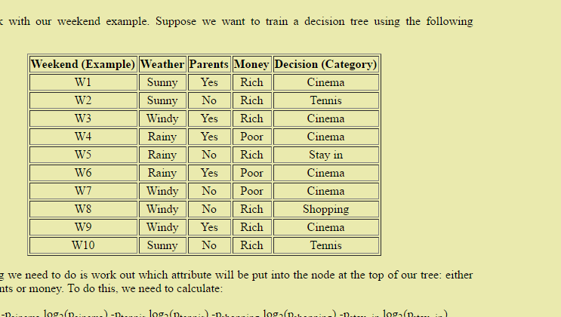
Let’s create a decision tree from scratch without a programming tool.

2. First we need to work out which attribute will be the root node for the decision tree.
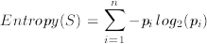
Given an arbitrary categorisation, C into categories c1, ..., cn, and a set of examples, S, for which the proportion of examples in ci is pi, then the entropy of S is:

Calculate entropy of S. Hint : For this question, p₁ could be weather….
Consider using wolfram alpha to solve the problems.
P_{x} = probability for x to occur.

Entropy(S, weather) = -p_{sunny}*log2(p_{sunny}) – p_{windy}*log2(p_{windy}) – ...
= -[ (0.3)*log2(0.3) + (0.4)*log2(0.4) + (0.3)*log2(0.3) ]
= 1.57095

Entropy(S, category) = -pcinema*log2(pcinema) – ptennis*log2(ptennis) - ...
= -[ (0.6)*log2(0.6) + (0.2)*log2(0.2) + (0.1)*log2(0.1) + (0.1)*log2(0.1) ]
= 1.57095

...

3. Next we need to calculate the best of the following formula:
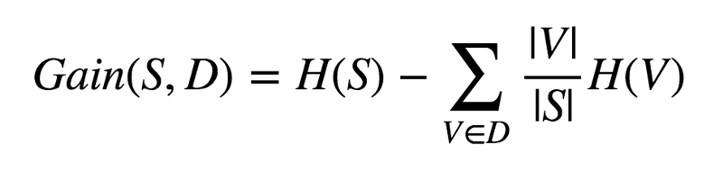
Gain(S, weather)
Entropy(S, weather_{sunny}) = - [ (1/3)*log2(1/3) + (2/3)*log2(2/3) ]
= 0.9182

Entropy(S, weather_{windy}) = - [ (1/4)*log2(1/4) + (3/4)*log2(3/4) ]
= 0.8113

Entropy(S, weather_{rainy}) = - [ (1/3)*log2(1/3) + (2/3)*log2(2/3) ]
= 0.9182

Gain(S, weather)
= Entropy(S, weather) –[ p_{sunny}*E(S, weather_{sunny}) + p_{windy}*E(S, weather_{windy}) + p_{rainy}*E(S, weather_{rainy}) ]
= 1.571 - [ (0.3)(0.9182) + (0.4)(0.8113) + (0.3)(0.9182) ]
= 0.7

* E(x) = Entropy(x) in the above example.

Gain(S, parents)
Entropy(S, parents) = - [ (5/10)*log2(5/10) + (5/10)*log2(5/10) ]
= 1

Entropy(S, parents_{yes}) = - [ (1/5)*log2(1/5) + (4/5)log2(4/5) ]
= 0.72

Entropy(S, parents_{no}) = 0.72

Gain(S, parents)
= 1 - [ (5/10)(0.72) + (5/10)(0.72) ]
= 0.28

Gain(S, money) ...

The feature with the highest gain will be the root node.
Repeat to decide branching nodes.

3. Draw your resulting decision tree.

4. Once you have decided on the tree, look at the activities based on weeks. For instance, assume you have chosen Weather, henceforth we investigate Sunny. For Sunny weather, the instances are W1,W2, W10 for which the activities are Cinema, Cinema, Tennis. As Cinema, Cinema and Tennis is present as a set and consists of non-Empty set, we will establish an attribute node, A. Do the same for the rest of your tree.

You may end up with something like the following
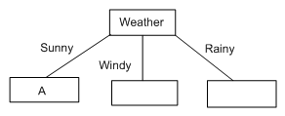

5. Now we have to fill in the choice of attribute A, which we know cannot be weather, because we've already removed that from the list of attributes to use. So, we need to calculate the values for Gain(S_{sunny}, parents) and Gain(S_{sunny}, money). Firstly, Entropy(S_{sunny}) = 0.918. Next, we set S to be S_{sunny} = {W1,W2,W10} (and, for this part of the branch, we will ignore all the other examples). In effect, we are interested only in this part of the table:

Weekend (Example) | Weather | Parents | Money | Decision (Category)
W1 | Sunny | Yes | Rich | Cinema
W2 | Sunny | No | Rich | Tennis
W10 | Sunny | No | Rich | Tennis

Calculate the following
Gain(S_{sunny}, parents) and Gain(S_{sunny}, money). Which has the higher gain, and what impact does that have on the selection of attribute A?

